# ECE 162 Week 8 – Voltage Analysis RC Circuit

Name: Brian Loughran (btl217@lehigh.edu)

## Purpose

In this lab we will determine phasor voltage across each element in an RC circuit

## Theory

In discussing phasor voltages across elements in an RC circuit, we should begin by discussing the concept of a phasor. A phasor is an element in the complex frequency domain, which represents values in the time domain such as amplitude (A), angular frequency (ω) and initial phase (θ).

The first step in converting to the frequency domain is to identify the frequency of the system. For analysis in this class the frequency of all voltage sources should be the same. Voltage is written following form:

$$V=A\cos\left(ft+ θ\right) \left(eq.1\right)$$

In equation 1, A is the amplitude of the voltage wave, f is the frequency, and θ is the initial phase angle. For this lab, we are using voltage amplitude of 1, a frequency of 100 rad/s, and an initial phase of 0. This frequency is not in the units that we want, however. In the phasor domain, we want units of (1/s). This can be gotten with the following equation

$$ω=2 π f (eq.2)$$

Where ω is the frequency in the phasor domain. This is the value we will use for frequency in subsequent equations.

Next we must convert all resistors, capacitors and inductors to the frequency domain. This is done by doing a complex impedance analysis which converts values to the frequency domain. The impedance of a given element in a circuit is commonly denoted as the letter Z. Equations to convert elements to the complex domain are as follows for resistors, capacitors, and inductors. Note that inductors are not utilized in this lab, but are included for reference.

$$Z_{R}=R (eq.3)$$

$$Z_{C}= \frac{-j}{ωC} (eq.4)$$

$$Z_{L}=j ω L (eq.5)$$

Now that all of the elements are in the complex frequency domain, we can treat them as resistors with complex values for resistance. This means that we can do KCL over the loop, and find the current going through the circuit. Using this information, we can calculate the voltage across each element using Ohm’s Law. All information will be given in the frequency domain, but this is OK. This will be gone over in more detail in the results section of this report.

## Experimental Method

* Connect a resistor and capacitor in series. Use R = 100 Ω and C = 22μF. Apply a voltage of 1 < 0o at a frequency of 100 cycle/second.
* Plot voltages across each component using the DAQ
* Determine voltage amplitude and phase angle for each component
* Compare experimental and calculated values

## Diagram

The circuit that we are using was described above in the experimental method section, but is also shown here in diagram form (Figure 1):

Figure 1

We are using values of R = 100 Ω, C = 22μF, and V = 1 < 0o for this experiment.

Shown below is a figure describing our LabView block diagram. This is mildly more complex than the previous LabView block diagram, as in this lab we are plotting two waveforms on the same plot. This requires two inputs for the sampling rate. The block diagram is included below in Figure 2:

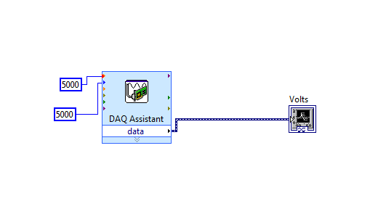

Figure 2

## Results

First we will calculate theoretical values for the voltage across each element of the circuit. The voltage across the voltage source was given, so our task is to calculate voltage across the resistor and the capacitor.

The first step to this is to calculate the current going through the circuit. This is found by taking the voltage across the system and dividing by the total impedance (Zeq). This operation is shown below in equation 6:

$$I=\frac{V}{Z_{eq}}=\frac{1<0}{123.42< -54.11}= .0081<54.11 (eq.6)$$

Using this, we can calculate the voltage across each element in the circuit using Ohm’s Law. This operation is shown below in equations 7 and 8.

$$V_{R}= I Z_{R}= .81<54.11 \left(eq.7\right)$$

$$V_{C}=I Z_{C}= .59<144.11 (eq.8)$$

Notice that the phase angle between the resistor and capacitor is 90 degrees. We can “zero out” the phase angle between the voltage source and the resistor because there is effectively no time delay between the voltage source and resistor. Then, the time delay between the voltage source and resistor is zero, and the time delay between these two and the capacitor is 90 degrees.

Moving on to the experimental results, we used the data acquisition unit to plot waveforms of the voltages across both the resistor and capacitor. A plot of general behavior of both waveforms plotted on the same axis is shown below (Figure 3):

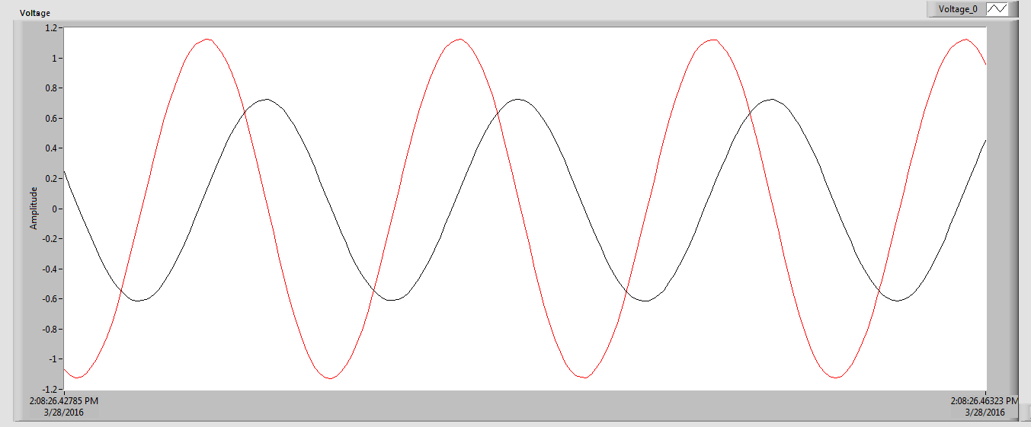

## Figure 3

This shows the way that the two waveforms look imposed on top of eachother. From this plot it is tough to see the amplitude, phase, and other important behavioral elements of each waveform, but this plot gives a pretty good picture of what is going on in the system. For this plot and subsequent plots, the red line (greater amplitude, leads capacitor voltage) is for the resistor voltage, and the blue line (lesser amplitude, lags resistor voltage) is for the capacitor.

First we would like to check the amplitude of each waveform. Using the previous figure (Figure 3) gives a good picture of what is going on overall, but does not help much for getting an accurate reading for amplitude. We will start with the resistor amplitude. This is analyzed in Figure 4 below:

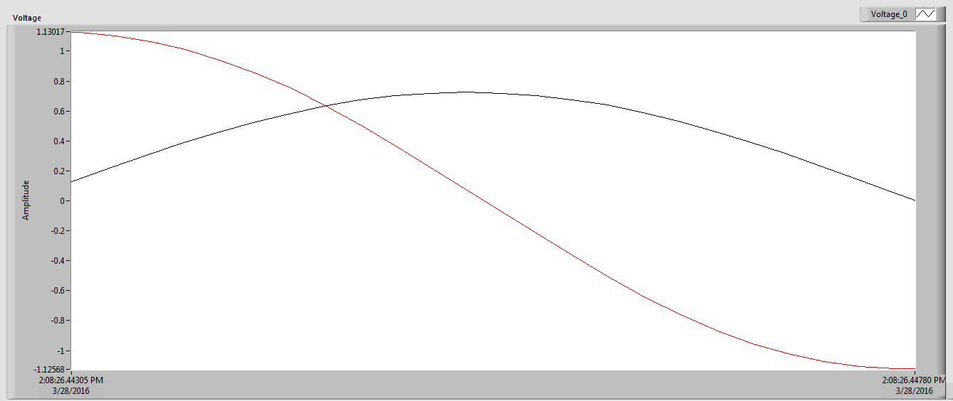

Figure 4

In this figure, we can see the resistor voltage through one fourth of its cycle. This is helpful in analyzing the amplitude, as it starts at its maximum value, and moves toward its minimum value. The capacitor voltage is also seen on this plot, but this is not a very good view of the capacitor voltage, so we ignore this. By subtracting the numbers on the y axis and dividing by 2, we are able to find the amplitude for the resistor, which is 1.12 volts.

We can do a similar analysis on the capacitor voltage with a better view of the capacitor waveform. This is supplied below in Figure 5

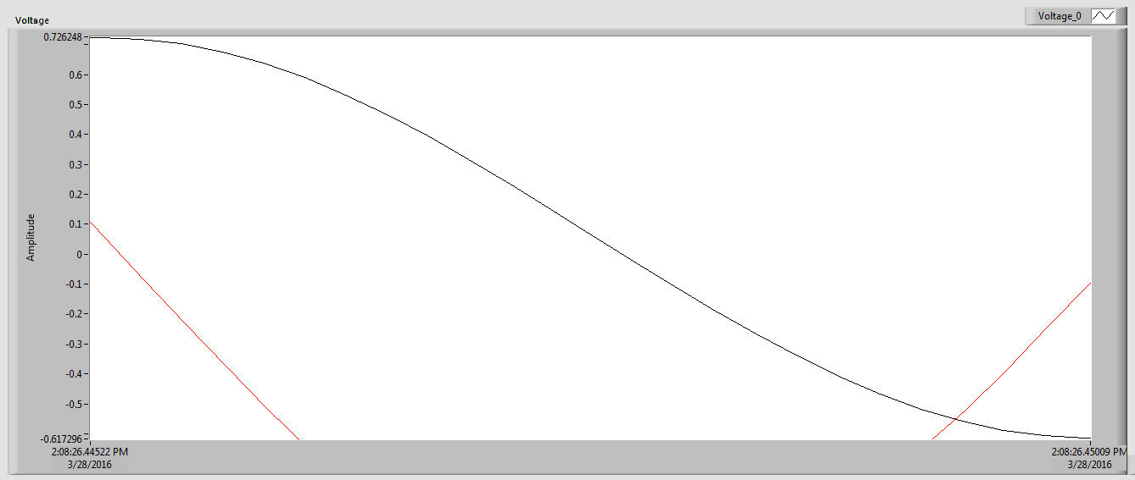

Figure 5

Figure 5 is similar to Figure 4 in that you can see the capacitor voltage through one fourth of its cycle, and that it moves from maximum voltage to minimum voltage. Again, the window we are using for the resistor voltage is not very helpful, so we ignore the resistor voltage in this instance. Analyzing the numbers on the y axis, we can find the voltage amplitude for the capacitor, which is .67 volts.

The other aspect which we were to analyze was the phase angle between the two waveforms for resistor voltage and capacitor voltage. This was done by utilizing the following equation:

$$θ= \frac{Time between peaks}{Waveform period}*360 \left(eq.9\right)$$

The first aspect which we must find is the time distance between peaks. Again, using an improved window through which to view the data, we can find this quite easily in LabView. This improved window is shown below in figure 6

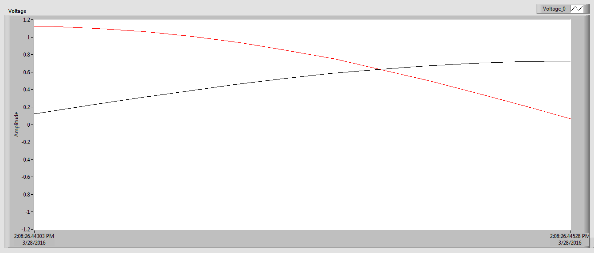

## Figure 6

This figure shows the time between the two peaks. The capacitor peak is shown on the left, and the resistor peak is shown on the right. The time between these two is measured to be .00225 seconds.

Next we need to find the waveform period. The period is the same for both the resistor and capacitor, so a plot of one period will also be a plot of the other period, and either period will work for our calculations. This is shown below in Figure 7:

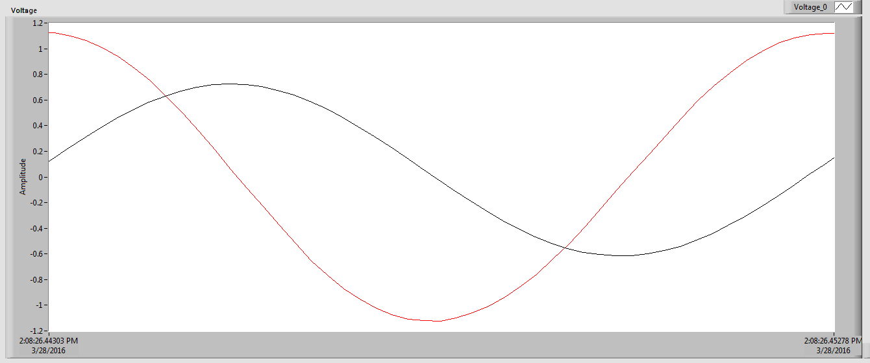

## Figure 7

This shows a full period of both waveforms. As mentioned above, the period is the same for each. While the resistor waveform resembles a negative cosine, the capacitor waveform resembles a positive sine wave. It is impossible to have both the capacitor and resistor waveforms resemble the same trigonometric function, because they are out of phase. The time calculated from this plot for the period of both waveforms is .00975 seconds.

Using equation 9, we can calculate that the phase angle between the two waveforms. This phase angle comes out to be 83.08 degrees.

## Discussion

The results from the previous section were compiled into a table in order to more easily compare experimental and calculated values. This table is shown below (Table 1):

|  |  |  |  |
| --- | --- | --- | --- |
|  | VR (V) | VC (V) | Θ (degrees) |
| Experimental | 1.12 | .67 | 83.08 |
| Calculated | .81 | .59 | 90 |
| % error | 32.1% | 12.7% | 8.0% |

Table 1

As you can see, while the experimental results generally follow the calculated results, there is some percent error between the experimental and calculated results. The first thing I notice is that both experimental voltages are higher than the expected voltage. This would lead me to believe that there is some sort of systematic error in the system. Because there are so many wires and different pieces of this system, I would think that some systematic error would be highly likely.

Another source of error is incorrectly framing the LabView window around the places where you want to analyze. For example, if you are trying to frame one period of a waveform (similar to Figure 7) there may be some error centering edge of the window on the peak that you want to analyze. This would cause your time stamps to be slightly off, and effect your measurement for the period you want to analyze. These two sources are the most likely sources of error in the system, and likely caused these relatively high percent errors.

## Conclusion

This lab was interesting because it produced a clear picture of what was going on in the system. We were charting two sinusoidal waves with different amplitudes and out of phase 90 degrees from each other. This is seen very clearly when looking at the whole picture (Figure 3), and all plots were remarkably smooth. Using the DAQ, we were able to easily and clearly see the changes in voltage across both the resistor and capacitor. This was done by creating a VI in LabVIEW to take in signals from the DAQ and process those signals into a plot which could be formatted to our needs. This gave great data, even though it did not precisely line up with the calculated values. Being able to fit the chart around whatever data we want to analyze proved hugely useful for us in this lab.